**Unit 7 Review Sheet**

**Pythagorean Theorem**

Find the value of *x.* Express your answer in simplest radical form.

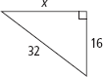**Untitled-7**

**Special Right Triangles**

Find the value of *x.* Express your answer in simplest radical form.

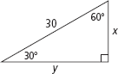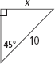

**Trigonometric Ratios**

1. In a right triangle, *ABC*, where angle C is 90 degrees, which of the following statements is always true? Circle one and explain why in one sentence.

a. sin *A* = tan *B*

b. sin *A* = cos *B*

c. cos *A* = tan *B*

d. tan *A* = tan *B*

Explanation: ___________________________________________________________________________________________________  
__________________________________________________________________________________________________________________

__________________________________________________________________________________________________________________

Screen%20Shot%202017-02-16%20at%208.47.58%20AM.png2.

**Using Trigonometry to Solve for Sides**

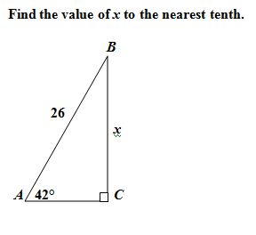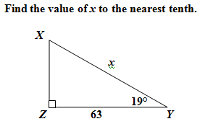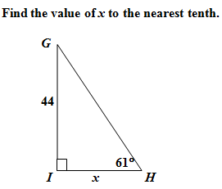

**Using Trigonometry to Solve for Angles**

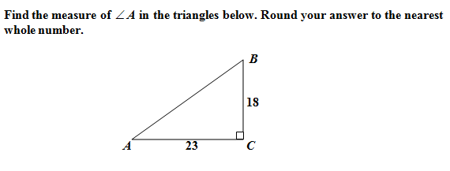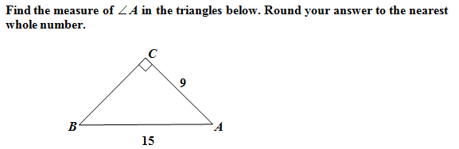

**Angle of Elevation & Angle of Depression**

